**Some Documentation and improtant issues**

Tags:

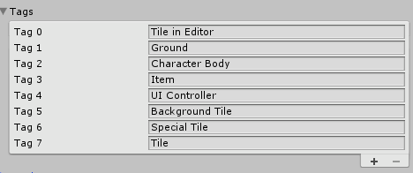

* Tile in editor tag is for tiles in editor scene, we set this on tiles by script
* Ground I don’t remember ☹ but I think I don’t use it
* Character body is for the character body parts
* Item is for pickable items
* UI controller is for main scene canvas
* Background Tile is for the darker tiles
* Special tiles, is for the tiles like trees, vegetatios, mushroom, and those tiles for decoration
* Tile is I don’t remember ☹

Sorting Layers:

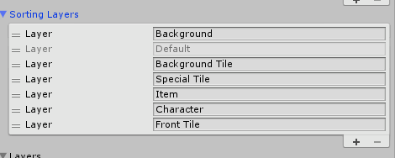

Layers:

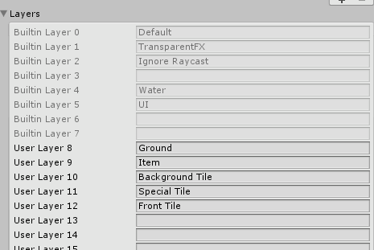

Important about layers:

First i had to tell that the world is divided by tree layers but only can be placed 2 tiles on same position.

Background tiles layer – Special tile layer – front tile layers

Lets name background tile as BT, special tile as ST and front tile as FT

so the possible combination for tiles and its result are:

* BT alone: character won’t collide.
* ST alone: character won’t collide.
* FT alone: character won’t collide.
* BT and ST (it means a ST over a BT): character won’t collide.
* ST and FT: character won’t collide.
* BT FT: will collide and we set the FT to a new layer called Ground that is where player can walk
* Other possible combinations aren’t available.

So you must have that clear when creating a world file.

World Files:

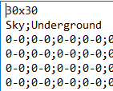

The first line is the world size

NomberOfRows x NumberOfColums

The second is the background and its by default.

And the is the world matrix cell by cell divided by a ‘;’

The cell has this structure: tile1Code-tile2Code. In example is 0-0 that means a emty space.

Each tile has its code, what on xlsx file or in TileCodification Class inside project.

If there any problem with the unityPackage file, you can download the project folder on this link:

https://www.dropbox.com/sh/jod42ta9qtr4uz7/AAAbHKh6sAkgRyhZwPowuAKua?dl=0